First Congregational
United Church of Christ
218 W. Second St., Gaylord, Michigan 49735
www.firstuccgaylord.org
June 21st, 2020
Father’s Day

Welcome to the First Congregational United Church of Christ. No matter who you are or where you are on life’s journey, you are welcome here!

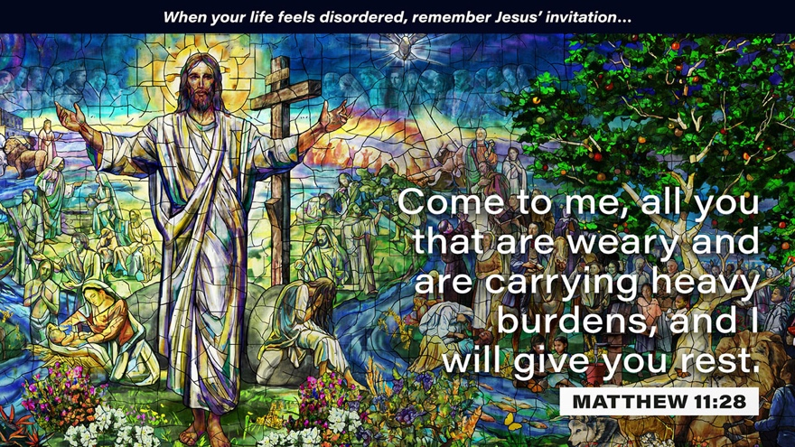

Our mission is to embrace people of every age and stage of life and help them become the most loving version of themselves possible.

~ Words of Welcome ~

*Call to Worship: (WL = Worship Leader, M= Ministers)
WL: When our world is turned upside down,
M: Let us hold on to God’s promise of hope.
WL: In the face of uncertainty,
M: Let us recall God’s promise of hope.
WL: In the face of fear,
M: and in moments of darkness,
ALL: Let us reach to our God of All for hope.

Corporate Unison Prayer
God, I am your humble servant, I come before you today in need of hope.
I need hope for a calm and joyful future. I need hope for love and kindness.
I pray for peace and safety. Some say that the sky is at its
darkest just before the light.
I pray that this is true, for today seems stormy and dim.
I need your light, God, in every way. I pray to be filled with your light.
Help me to walk in your light, and live
my life in faith and service and to offer hope to others.
In your name I pray, Amen.

Hymn
“Forward Through the Ages”

1st Scripture Reading
Jeremiah 29: 11-13

Special Music
My Father
By Judy Collins
Performed by Anna Fry and Rokko Jans

Children’s Time
A Hope Giving Family

2nd Scripture Reading
Matthew 11: 28-30

Sermon
“Two Men of Hope”
Don Sotring

Special Music
Imagine
By John Lennon
Performed by Rokko Jans, Melissa Mannion and Joanna Morse

Feast of Love
Maggie Wallin
(she sent you the prayer)

Offering
At this time, you may mail in your contributions to the church:
218 W. 2nd St. Gaylord, MI 49735

The Doxology
Praise God from whom all blessings flow/Praise God, all creatures here below/Praise God for all that Love has done/Creator, Christ, and Spirit, One.

Prayers of the People

Benediction
We thank You, Lord, for re-igniting the flame of hope within us, for filling our hearts with light and evicting the darkness, and for giving a new vision of Your glory. Go now, as light-bearers to a world in darkness, Go now, as hope-carriers to a world in despair; Go in the name of Christ, in the love of God
and in the power of the Spirit. Amen.



SUNDAY PARTICIPANTS:
Sermon Leader: Don Storing
Music Director: Rokko Jans
Liturgist: Paul Balliet
Children’s Message: Brenda Brummel
Altar & Banner Design: Helen Mate

Moderator  Rokko Jans  E-mail: rokko@alaricjans.com | Communications Coordinator  Jessica Benoit  989-732-5726  E-mail: office@firstuccgaylord.org
ANNOUNCEMENTS
COVID -19

If you must be isolated during the COVID-19 crisis, please let the Church Office know 989-732-5726 or office@firstuccgaylord.org so we can call or visit you as well as keep you in the prayers of the congregation.

A Notice from Women’s Fellowship – unless an emergency arises, all events pertaining to WF have been cancelled at this time, this includes the rummage sale. A suggestion regarding salad luncheons has been made to Council.

Jeannine Wambold – would like to thank everyone for lifting her son-in-law, Jordan, in prayer. He is healing from his broken ribs.

Don Storing needs volunteers to help share the lawn mowing responsibilities this season. If you can help, please contact him directly: 989-464-9648 snod34@chartermi.net

Virtual Coffee Hour - click the following link to join our virtual coffee hour this Sunday between 10:45 – 11 am; https://us02web.zoom.us/j/83811276546 call or text Rokko (773) 398-6767 or Brenda (810) 623-1691 if you have any difficulties connecting. Dial in phone number is: (929) 205 6099

Through the years, Alpine Oven has been so supportive of our church. They have provided us with food and more recently the venue for our fund raiser for Kids on a Mission. We want to let you know that both Alpine Tavern and Crave are open for carry out service.

Happenings at Church
For the week of June 21st, 2020

Sunday: Virtual Worship, 10:00am
Virtual Coffee Hour, 10:45am
Tuesday: Reaching In via Zoom, 12:00pm
Wednesday: Reaching Out via Zoom, 11:00am (if needed)
Thursday: Bible Study via Zoom, 11:00am
Friday: Drive-Thru Community Meal, 4:00pm

~ In Our Prayers ~
During the month of June, the UNA is holding the Manistee church in prayer.

Chuck Falk and Family – as they grieve the loss of Judy.
The Family of Shirley Matevia – as they grieve her passing.
The People of Mid-Michigan - as they deal with the catastrophic flooding.
Carol Leser’s sister, Barbara Loomis – whose Gladwin home was flooded in the mid- Michigan catastrophe.
Bo Leser – As he continues to experience health issues and is awaiting testing.
Cleveann Wolf – as she is now in a memory care facility.
Doug Fopma – Doug has made huge strides! He is now recovering in a rehabilitation center in Grand Rapids and still in need of prayers.
Doug Galer – who is also hospitalized and fighting to recover from COVID-19.
All of those working on the frontline to fight COVID-19, those that are considered essential workers, those without jobs, those ill, and those affected by this pandemic in anyway.
Norman Reim - Rokko’s bandmate, as he recovers from recent surgery.
Don Storing’s longtime friend, Eric Larsen – as he navigates his recent stage IV lung and brain cancer diagnosis.
Lani English and Family – as they grieve the passing of Lani’s cousin, Adam.
Margaret Soller – as she grieves the loss of her twin sister, Liz.
Marcus and Samantha Fray – as they navigate Marcus’s recent ALS diagnosis. Marcus is married to George and Judy Dunn’s granddaughter. He is in his thirties with two small children.
Rev. Ginny Titus and Family

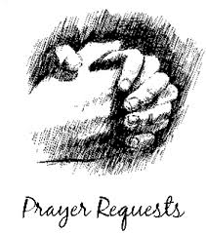
See the prayer request / joys sheet in the Narthex to add to this list. If someone has been inadvertently omitted or if it is time to remove a name, please let the church office know.

During this time of transition, if you have pastoral concerns, please contact the church office and Jessica will notify the Reaching In team.

